**UNIT - III**

**PRODUCTION FUNCTION**

**Introduction:** The production function expresses a functional relationship between physical inputs and physical outputs of a firm at any particular time period. The output is thus a function of inputs. Mathematically production function can be written as

Q= f (L1, L2, K, O, T)

Where “Q” stands for the quantity of output and A, B, C, D are various input factors such as land, labour, capital, organization and technology. Here output is the function of inputs. Hence output becomes the dependent variable and inputs are the independent variables.

The above function does not state by how much the output of “Q” changes as a consequence of change of variable inputs. In order to express the quantitative relationship between inputs and output, Production function has been expressed in a precise mathematical equation i.e.

Y= a+b(x)

Which shows that there is a constant relationship between applications of input (the only factor input ‘X’ in this case) and the amount of output (y) produced.

**Importance:**

1. When inputs are specified in physical units, production function helps to estimate the level of production.
2. It becomes is equates when different combinations of inputs yield the same level of output.
3. It indicates the manner in which the firm can substitute on input for another without altering the total output.
4. When price is taken into consideration, the production function helps to select the least combination of inputs for the desired output.
5. It considers two types’ input-output relationships namely ‘law of variable proportions’ and ‘law of returns to scale’. Law of variable propositions explains the pattern of output in the short-run as the units of variable inputs are increased to increase the output. On the other hand law of returns to scale explains the pattern of output in the long run as all the units of inputs are increased.
6. The production function explains the maximum quantity of output, which can be produced, from any chosen quantities of various inputs or the minimum quantities of various inputs that are required to produce a given quantity of output.
7. Production function can be fitted the particular firm or industry or for the economy as whole. Production function will change with an improvement in technology.

**Assumptions:**

1. The production function is related to a particular period of time.
2. There is no change in technology.
3. The producer is using the best techniques available.
4. The factors of production are divisible.
5. Production function can be fitted to a short run or to long run.

**COBB-DOUGLAS PRODUCTION FUNCTION**

Production function of the linear homogenous type is invested by Junt wicksell and first tested by C. W. Cobb and P. H. Dougles in 1928. This famous statistical production function is known as Cobb-Douglas production function. Originally the function is applied on the empirical study of the American manufacturing industry. Cobb – Douglas production function takes the following mathematical form.

**Y= AKb L(1-b)**

Where Y=output

K=Capital

L=Labour

A, ∞=positive constant

**Assumptions:**

1. The function assumes that output is the function of two factors viz. capital and labour.
2. It is a linear homogenous production function of the first degree
3. The function assumes that the logarithm of the total output of the economy is a linear function of the logarithms of the labour force and capital stock.
4. There are constant returns to scale
5. All inputs are homogenous
6. There is perfect competition
7. There is no change in technology

**ISOQUANTS**

The term Isoquants is derived from the words ‘Iso’ and ‘quant’ – ‘Iso’ means equal and ‘quant’ implies quantity. Isoquant therefore, means equal quantity. A family of iso-product curves or isoquants or production difference curves can represent a production function with two variable inputs, which are substitutable for one another within limits. Isoquants are the curves, which represent the different combinations of inputs producing a particular quantity of output. Any combination on the isoquant represents the some level of output.

For a given output level firm’s production become,

Q= f (L, K)

Where ‘Q’, the units of output is a function of the quantity of two inputs ‘L’ and ‘K’

Thus an isoquant shows all possible combinations of two inputs, which are capable of producing equal or a given level of output. Since each combination yields same output, the producer becomes indifferent towards these combinations.

**Assumptions:**

1. There are only two factors of production, viz. labour and capital.
2. The two factors can substitute each other up to certain limit
3. The shape of the isoquant depends upon the extent of substitutability of the two inputs.
4. The technology is given over a period.

An isoquant may be explained with the help of an arithmetical example.

|  |  |  |  |
| --- | --- | --- | --- |
| **Combinations** | **Labour (units)** | **Capital (Units)** | **Output (quintals)** |
| A | 1 | 10 | 50 |
| B | 2 | 7 | 50 |
| C | 3 | 4 | 50 |
| D | 4 | 4 | 50 |
| E | 5 | 1 | 50 |

Combination ‘A’ represent 1 unit of labour and 10 units of capital and produces ‘50’ quintals of a product all other combinations in the table are assumed to yield the same given output of a product say ‘50’ quintals by employing any one of the alternative combinations of the two factors labour and capital. If we plot all these combinations on a paper and join them, we will get continues and smooth curve called Iso-product curve as shown below.

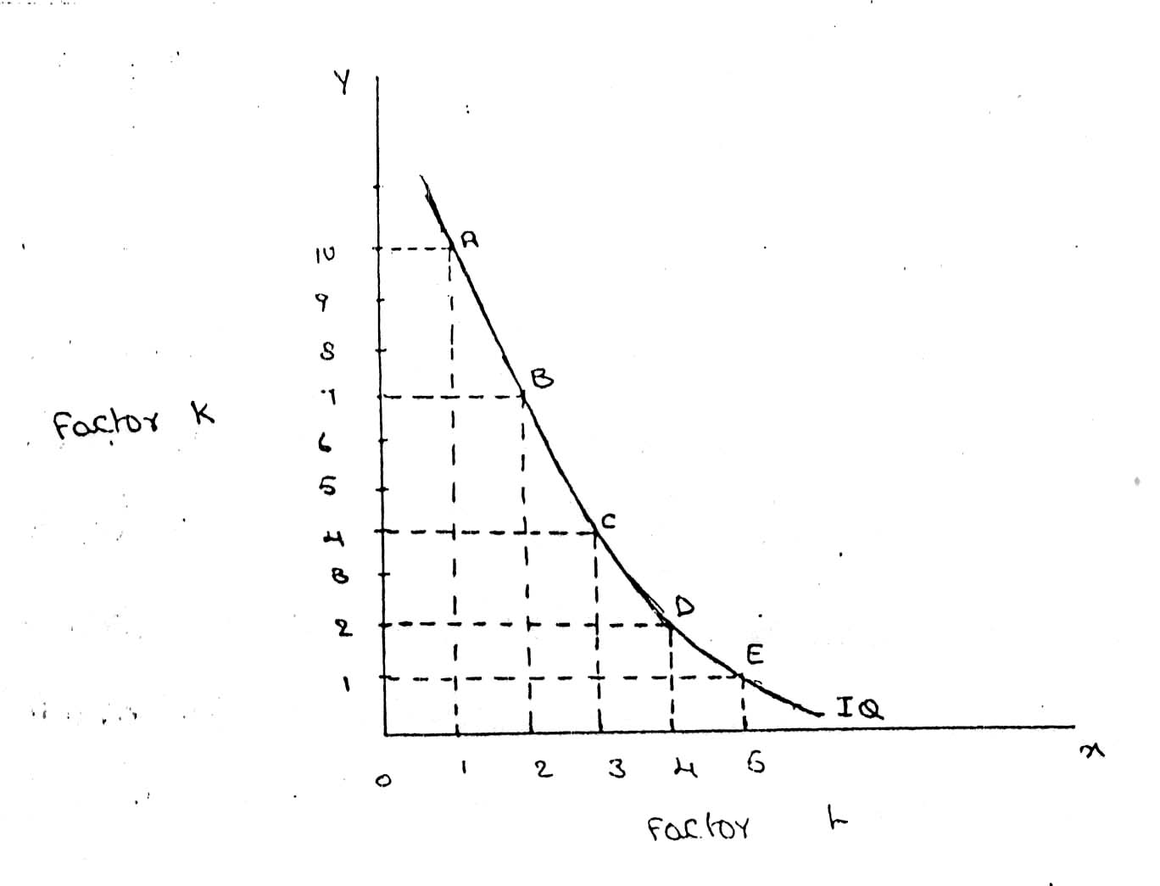

Labour is on the X-axis and capital is on the Y-axis. IQ is the ISO-Product curve which shows all the alternative combinations A, B, C, D, E which can produce 50 quintals of a product.

**LAW OF PRODUCTION**

Production analysis in economics theory considers two types of input-output relationships.

1. When quantities of certain inputs, are fixed and others are variable and
2. When all inputs are variable.

These two types of relationships have been explained in the form of laws.

1. Law of variable proportions
2. Law of returns to scale

I. Law of variable proportions:

The law of variable proportions which is a new name given to old classical concept of “Law of diminishing returns has played a vital role in the modern economics theory. Assume that a firms production function consists of fixed quantities of all inputs (land, equipment, etc.) except labour which is a variable input when the firm expands output by employing more and more labour it alters the proportion between fixed and the variable inputs. The law can be stated as follows:

“When total output or production of a commodity is increased by adding units of a variable input while the quantities of other inputs are held constant, the increase in total production becomes after some point, smaller and smaller”.

“If equal increments of one input are added, the inputs of other production services being held constant, beyond a certain point the resulting increments of product will decrease i.e. the marginal product will diminish”. (G. Stigler)

“As the proportion of one factor in a combination of factors is increased, after a point, first the marginal and then the average product of that factor will diminish”. (F. Benham)

The law of variable proportions refers to the behaviour of output as the quantity of one Factor is increased Keeping the quantity of other factors fixed and further it states that the marginal product and average product will eventually do cline. This law states three types of productivity an input factor – Total, average and marginal physical productivity.

**Assumptions of the Law:** The law is based upon the following assumptions:

1. The state of technology remains constant. If there is any improvement in technology, the average and marginal output will not decrease but increase.
2. Only one factor of input is made variable and other factors are kept constant. This law does not apply to those cases where the factors must be used in rigidly fixed proportions.
3. All units of the variable factors are homogenous.

**Three stages of law:**

The behaviours of the Output when the varying quantity of one factor is combines with a fixed quantity of the other can be divided in to three district stages. The three stages can be better understood by following the table.

|  |  |  |  |  |  |
| --- | --- | --- | --- | --- | --- |
| **Fixed factor** | **Variable factor (Labour)** | **Total product** | **Average Product** | **Marginal Product** | |
| 1 | 1 | 100 | 100 | - | Stage I |
| 1 | 2 | 220 | 120 | 120 |
| 1 | 3 | 270 | 90 | 50 |
| 1 | 4 | 300 | 75 | 30 | Stage II |
| 1 | 5 | 320 | 64 | 20 |
| 1 | 6 | 330 | 55 | 10 |
| 1 | 7 | 330 | 47 | 0 | Stage III |
| 1 | 8 | 320 | 40 | -10 |

Above table reveals that both average product and marginal product increase in the beginning and then decline of the two marginal products drops of faster than average product. Total product is maximum when the farmer employs 6th worker, nothing is produced by the 7th worker and its marginal productivity is zero, whereas marginal product of 8th worker is ‘-10’, by just creating credits 8th worker not only fails to make a positive contribution but leads to a fall in the total output.

Production function with one variable input and the remaining fixed inputs is illustrated as below

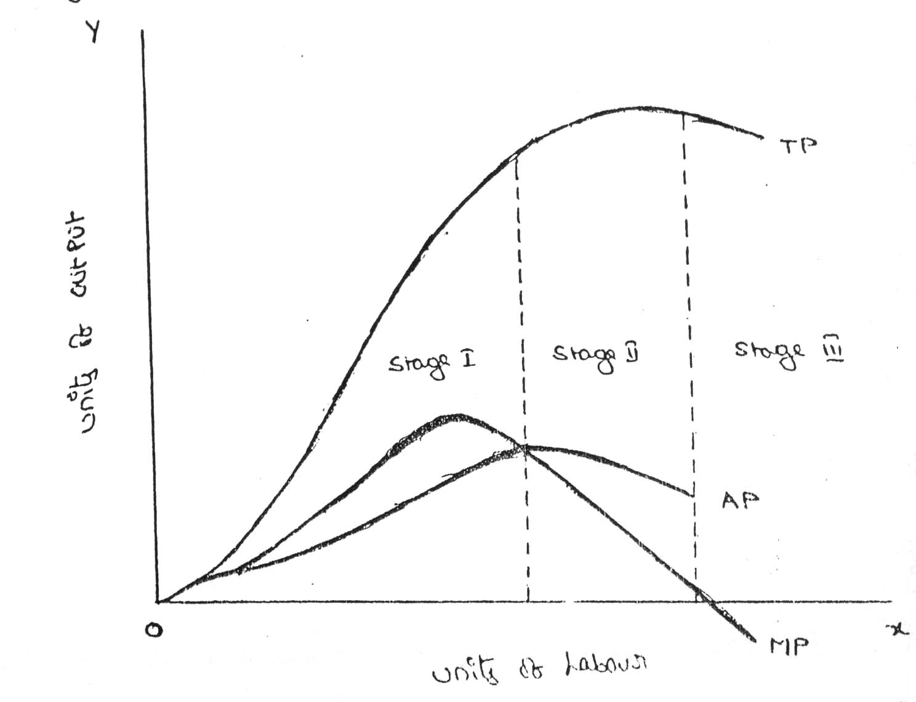

From the above graph the law of variable proportions operates in three stages. In the first stage, total product increases at an increasing rate. The marginal product in this stage increases at an increasing rate resulting in a greater increase in total product. The average product also increases. This stage continues up to the point where average product is equal to marginal product. The law of increasing returns is in operation at this stage. The law of diminishing returns starts operating from the second stage awards. At the second stage total product increases only at a diminishing rate. The average product also declines. The second stage comes to an end where total product becomes maximum and marginal product becomes zero. The marginal product becomes negative in the third stage. So the total product also declines. The average product continues to decline.

We can sum up the above relationship thus when ‘A.P.’ is rising, “M. P.’ rises more than “ A. P; When ‘A. P.” is maximum and constant, ‘M. P.’ becomes equal to ‘A. P.’ when ‘A. P.’ starts falling, ‘M. P.’ falls faster than ‘ A. P.’.

Thus, the total product, marginal product and average product pass through three phases, viz., increasing diminishing and negative returns stage. The law of variable proportion is nothing but the combination of the law of increasing and demising returns.

**II. Law of Returns of Scale:**

The law of returns to scale explains the behaviour of the total output in response to change in the scale of the firm, i.e., in response to a simultaneous to changes in the scale of the firm, i.e., in response to a simultaneous and proportional increase in all the inputs. More precisely, the Law of returns to scale explains how a simultaneous and proportionate increase in all the inputs affects the total output at its various levels.

The concept of variable proportions is a short-run phenomenon as in these period fixed factors cannot be changed and all factors cannot be changed. On the other hand in the long-term all factors can be changed as made variable. When we study the changes in output when all factors or inputs are changed, we study returns to scale. An increase in the scale means that all inputs or factors are increased in the same proportion. In variable proportions, the cooperating factors may be increased or decreased and one faster (Ex. Land in agriculture (or) machinery in industry) remains constant so that the changes in proportion among the factors result in certain changes in output. In returns to scale all the necessary factors or production are increased or decreased to the same extent so that whatever the scale of production, the proportion among the factors remains the same.

When a firm expands, its scale increases all its inputs proportionally, then technically there are three possibilities.

(i) The total output may increase proportionately

(ii) The total output may increase more than proportionately and

(iii) The total output may increase less than proportionately.

If increase in the total output is proportional to the increase in input, it means constant returns to scale. If increase in the output is greater than the proportional increase in the inputs, it means increasing return to scale. If increase in the output is less than proportional increase in the inputs, it means diminishing returns to scale.

**ECONOMIES OF SCALE**

Production may be carried on a small scale or o a large scale by a firm. When a firm expands its size of production by increasing all the factors, it secures certain advantages known as economies of production. Marshall has classified these economies of large-scale production into internal economies and external economies. Internal economies are those, which are opened to a single factory or a single firm independently of the action of other firms. They result from an increase in the scale of output of a firm and cannot be achieved unless output increases. Hence internal economies depend solely upon the size of the firm and are different for different firms. External economies are those benefits, which are shared in by a number of firms or industries when the scale of production in an industry or groups of industries increases. Hence external economies benefit all firms within the industry as the size of the industry expands.

**Internal Economies:**

1. **Technical Economies:**

Technical economies arise to a firm from the use of better machines and superior techniques of production. As a result, production increases and per unit cost of production falls. A large firm, which employs costly and superior plant and equipment, enjoys a technical superiority over a small firm. Another technical economy lies in the mechanical advantage of using large machines. The cost of operating large machines is less than that of operating mall machine. More over a larger firm is able to reduce it’s per unit cost of production by linking the various processes of production. Technical economies may also be associated when the large firm is able to utilize all its waste materials for the development of by-products industry. Scope for specialization is also available in a large firm. This increases the productive capacity of the firm and reduces the unit cost of production.

1. **Managerial Economies:**

These economies arise due to better and more elaborate management, which only the large size firms can afford. There may be a separate head for manufacturing, assembling, packing, marketing, general administration etc. Each department is under the charge of an expert. Hence the appointment of experts, division of administration into several departments, functional specialization and scientific co-ordination of various works make the management of the firm most efficient.

1. **Marketing Economies:**

The large firm reaps marketing or commercial economies in buying its requirements and in selling its final products. The large firm generally has a separate marketing department. It can buy and sell on behalf of the firm, when the market trends are more favourable. In the matter of buying they could enjoy advantages like preferential treatment, transport concessions, cheap credit, prompt delivery and fine relation with dealers. Similarly it sells its products more effectively for a higher margin of profit.

1. **Financial Economies:**

The large firm is able to secure the necessary finances either for block capital purposes or for working capital needs more easily and cheaply. It can barrow from the public, banks and other financial institutions at relatively cheaper rates. It is in this way that a large firm reaps financial economies.

1. **Risk bearing Economies:**

The large firm produces many commodities and serves wider areas. It is, therefore, able to absorb any shock for its existence. For example, during business depression, the prices fall for every firm. There is also a possibility for market fluctuations in a particular product of the firm. Under such circumstances the risk-bearing economies or survival economies help the bigger firm to survive business crisis.

1. **Economies of Research:**

A large firm possesses larger resources and can establish it’s own research laboratory and employ trained research workers. The firm may even invent new production techniques for increasing its output and reducing cost.

1. **Economies of welfare:**

A large firm can provide better working conditions in-and out-side the factory. Facilities like subsidized canteens, crèches for the infants, recreation room, cheap houses, educational and medical facilities tend to increase the productive efficiency of the workers, which helps in raising production and reducing costs.

**External Economies:**

1. **Economies of Concentration:**

When an industry is concentrated in a particular area, all the member firms reap some common economies like skilled labour, improved means of transport and communications, banking and financial services, supply of power and benefits from subsidiaries. All these facilities tend to lower the unit cost of production of all the firms in the industry.

1. **Economies of Information:**

The industry can set up an information centre which may publish a journal and pass on information regarding the availability of raw materials, modern machines, export potentialities and provide other information needed by the firms. It will benefit all firms and reduction in their costs.

1. **Economies of Welfare:**

An industry is in a better position to provide welfare facilities to the workers. It may get land at concessional rates and procure special facilities from the local bodies for setting up housing colonies for the workers. It may also establish public health care units, educational institutions both general and technical so that a continuous supply of skilled labour is available to the industry. This will help the efficiency of the workers.

1. **Economies of Disintegration:**

The firms in an industry may also reap the economies of specialization. When an industry expands, it becomes possible to spill up some of the processes which are taken over by specialist firms. For example, in the cotton textile industry, some firms may specialize in manufacturing thread, others in printing, still others in dyeing, some in long cloth, some in dhotis, some in shirting etc. As a result the efficiency of the firms specializing in different fields increases and the unit cost of production falls.

Thus internal economies depend upon the size of the firm and external economies depend upon the size of the industry.

**COST ANALYSIS**

Profit is the ultimate aim of any business and the long-run prosperity of a firm depends upon its ability to earn sustained profits. Profits are the difference between selling price and cost of production. In general the selling price is not within the control of a firm but many costs are under its control. The firm should therefore aim at controlling and minimizing cost. Since every business decision involves cost consideration, it is necessary to understand the meaning of various concepts for clear business thinking and application of right kind of costs.

**Cost Concepts:**

A managerial economist must have a clear understanding of the different cost concepts for clear business thinking and proper application. The several alternative bases of classifying cost and the relevance of each for different kinds of problems are to be studied. The various relevant concepts of cost are:

1. **Opportunity costs and outlay costs:**

Out lay cost also known as actual costs obsolete costs are those expends which are actually incurred by the firm these are the payments made for labour, material, plant, building, machinery travelling, transporting etc., These are all those expense item appearing in the books of account, hence based on accounting cost concept. On the other hand opportunity cost implies the earnings foregone on the next best alternative, has the present option is undertaken. This cost is often measured by assessing the alternative, which has to be scarified if the particular line is followed. The opportunity cost concept is made use for long-run decisions. The concept is also useful for taking short-run decisions opportunity cost is the cost concept to use when the supply of inputs is strictly limited and when there is an alternative. If there is no alternative, Opportunity cost is zero. The opportunity cost of any action is therefore measured by the value of the most favourable alternative course, which had to be foregoing if that action is taken.

1. **Explicit and implicit costs:**

Explicit costs are those expenses that involve cash payments. These are the actual or business costs that appear in the books of accounts. These costs include payment of wages and salaries, payment for raw-materials, interest on borrowed capital funds, rent on hired land, Taxes paid etc. Implicit costs are the costs of the factor units that are owned by the employer himself. These costs are not actually incurred but would have been incurred in the absence of employment of self – owned factors. The two normal implicit costs are depreciation, interest on capital etc. A decision maker must consider implicit costs too to find out appropriate profitability of alternatives.

1. **Historical and Replacement costs:**

Historical cost is the original cost of an asset. Historical cost valuation shows the cost of an asset as the original price paid for the asset acquired in the past. Historical valuation is the basis for financial accounts. A replacement cost is the price that would have to be paid currently to replace the same asset. During periods of substantial change in the price level, historical valuation gives a poor projection of the future cost intended for managerial decision. A replacement cost is a relevant cost concept when financial statements have to be adjusted for inflation.

1. **Short – run and long – run costs:**

Short-run is a period during which the physical capacity of the firm remains fixed. Any increase in output during this period is possible only by using the existing physical capacity more extensively. So short run cost is that which varies with output when the plant and capital equipment in constant. Long run costs are those, which vary with output when all inputs are variable including plant and capital equipment. Long-run cost analysis helps to take investment decisions.

1. **Out-of pocket and books costs:**

Out-of pocket costs also known as explicit costs are those costs that involve current cash payment. Book costs also called implicit costs do not require current cash payments. Depreciation, unpaid interest, salary of the owner is examples of back costs. But the book costs are taken into account in determining the level dividend payable during a period. Both book costs and out-of-pocket costs are considered for all decisions. Book cost is the cost of self-owned factors of production.

1. **Fixed and variable costs:**

Fixed cost is that cost which remains constant for a certain level to output. It is not affected by the changes in the volume of production. But fixed cost per unit decrease, when the production is increased. Fixed cost includes salaries, Rent, Administrative expenses depreciations etc. Variable is that which varies directly with the variation is output. An increase in total output results in an increase in total variable costs and decrease in total output results in a proportionate decline in the total variables costs. The variable cost per unit will be constant. Ex: Raw materials, labour, direct expenses, etc.

1. **Post and Future costs:**

Post costs also called historical costs are the actual cost incurred and recorded in the book of account these costs are useful only for valuation and not for decision making. Future costs are costs that are expected to be incurred in the futures. They are not actual costs. They are the costs forecasted or estimated with rational methods. Future cost estimate is useful for decision making because decision are meant for future.

1. **Traceable and common costs:**

Traceable costs otherwise called direct cost, is one, which can be identified with a products process or product. Raw material, labour involved in production is examples of traceable cost. Common costs are the ones that common are attributed to a particular process or product. They are incurred collectively for different processes or different types of products. It cannot be directly identified with any particular process or type of product.

1. **Avoidable and unavoidable costs:**

Avoidable costs are the costs, which can be reduced if the business activities of a concern are curtailed. For example, if some workers can be retrenched with a drop in a product – line, or volume or production the wages of the retrenched workers are escapable costs. The unavoidable costs are otherwise called sunk costs. There will not be any reduction in this cost even if reduction in business activity is made. For example cost of the ideal machine capacity is unavoidable cost.

1. **Controllable and uncontrollable costs:**

Controllable costs are ones, which can be regulated by the executive who is in charge of it. The concept of controllability of cost varies with levels of management. Direct expenses like material, labour etc. are controllable costs. Some costs are not directly identifiable with a process of product. They are appointed to various processes or products in some proportion. This cost varies with the variation in the basis of allocation and is independent of the actions of the executive of that department. These apportioned costs are called uncontrollable costs.

1. **Incremental and sunk costs:**

Incremental cost also known as different cost is the additional cost due to a change in the level or nature of business activity. The change may be caused by adding a new product, adding new machinery, replacing a machine by a better one etc. Sunk costs are those which are not altered by any change – They are the costs incurred in the past. This cost is the result of past decision, and cannot be changed by future decisions. Investments in fixed assets are examples of sunk costs.

1. **Total, average and marginal costs:**

Total cost is the total cash payment made for the input needed for production. It may be explicit or implicit. It is the sum total of the fixed and variable costs. Average cost is the cost per unit of output. If is obtained by dividing the total cost (TC) by the total quantity produced (Q)

**Average cost= $\frac{TC}{Q}$**

Marginal cost is the additional cost incurred to produce and additional unit of output or it is the cost of the marginal unit produced.

1. **Accounting and Economics costs:**

Accounting costs are the costs recorded for the purpose of preparing the balance sheet and profit and ton statements to meet the legal, financial and tax purpose of the company. The accounting concept is a historical concept and records what has happened in the post. Economics concept considers future costs and future revenues, which help future planning, and choice, while the accountant describes what has happened, the economics aims at projecting what will happen.

**COST-OUTPUT RELATIONSHIP**

A proper understanding of the nature and behaviour of costs is a must for regulation and control of cost of production. The cost of production depends on money forces and an understanding of the functional relationship of cost to various forces will help us to take various decisions. Output is an important factor, which influences the cost. The cost-output relationship plays an important role in determining the optimum level of production. Knowledge of the cost-output relation helps the manager in cost control, profit prediction, pricing, promotion etc. The relation between cost and its determinants is technically described as the cost function.

**C= f (S, O, P, T ….)**

Where;

C= Cost (Unit or total cost)

S= Size of plant/scale of production

O= Output level

P= Prices of inputs

T= Technology

Considering the period the cost function can be classified as:

(a) short-run cost function and

(b) long-run cost function.

In economics theory, the short-run is defined as that period during which the physical capacity of the firm is fixed and the output can be increased only by using the existing capacity allows to bring changes in output by physical capacity of the firm.

* 1. **Cost-Output Relation in the short-run:**

The cost concepts made use of in the cost behaviour are total cost, Average cost, and marginal cost. Total cost is the actual money spent to produce a particular quantity of output. Total cost is the summation of fixed and variable costs.

**TC = TFC + TVC**

Up to a certain level of production total fixed cost i.e., the cost of plant, building, equipment etc, remains fixed. But the total variable cost i.e., the cost of labour, raw materials etc., Vary with the variation in output. Average cost is the total cost per unit. It can be found out as follows.­­­­­­­­

AC= 

The total of average fixed cost (TFC/Q) keep coming down as the production is increased and average variable cost (TVC/Q) will remain constant at any level of output. Marginal cost is the addition to the total cost due to the production of an additional unit of product. It can be arrived at by dividing the change in total cost by the change in total output. In the short-run there will not be any change in total fixed cost. Hence change in total cost implies change in total variable cost only.

**Cost - output relations**

|  |  |  |  |  |  |  |  |
| --- | --- | --- | --- | --- | --- | --- | --- |
| **Q** | **TFC** | **TVC** | **TC** | **AVC** | **AFC** | **AC** | **MC** |
| 0 | - | - | 60 | - | - | - | - |
| 1 | 60 | 20 | 80 | 20 | 60 | 80 | 20 |
| 2 | 60 | 36 | 96 | 18 | 30 | 48 | 16 |
| 3 | 60 | 48 | 108 | 16 | 20 | 36 | 12 |
| 4 | 60 | 64 | 124 | 16 | 15 | 31 | 16 |
| 5 | 60 | 90 | 150 | 18 | 12 | 30 | 26 |
| 6 | 60 | 132 | 192 | 22 | 10 | 32 | 42 |

Q = Units of output

TFC = Total Fixed Cost

TVC = Total Variable Cost

TC = Total Cost [TFC+TVC]

AVC = Average Variable Cost [TVC/Q]

AFC = Average Fixed Cost [TFC/Q]

AC = Average Cost [TC/Q]

MC = Marginal Cost

The above table represents the cost-output relation. The table is prepared on the basis of the law of diminishing marginal returns. The fixed cost Rs. 60 May include rent of factory building, interest on capital, salaries of permanently employed staff, insurance etc. The table shows that fixed cost is same at all levels of output but the average fixed cost, i.e., the fixed cost per unit, falls continuously as the output increases. The expenditure on the variable factors (TVC) is at different rate. If more and more units are produced with a given physical capacity the AVC will fall initially, as per the table declining up to 3rd unit, and being constant up to 4th unit and then rising. It implies that variable factors produce more efficiently near a firm’s optimum capacity than at any other levels of output.

And later rises. But the rise in AC is felt only after the start rising. In the table ‘AVC’ starts rising from the 5th unit onwards whereas the ‘AC’ starts rising from the 6th unit only so long as ‘AVC’ declines ‘AC’ also will decline. ‘AFC’ continues to fall with an increase in Output. When the rise in ‘AVC’ is more than the decline in ‘AFC’, the total cost again begin to rise. Thus there will be a stage where the ‘AVC’, the total cost again begin to rise thus there will be a stage where the ‘AVC’ may have started rising, yet the ‘AC’ is still declining because the rise in ‘AVC’ is less than the drop in ‘AFC’.

Thus the table shows an increasing returns or diminishing cost in the first stage and diminishing returns or diminishing cost in the second stage and followed by diminishing returns or increasing cost in the third stage.

The short-run cost-output relationship can be shown graphically as follows.

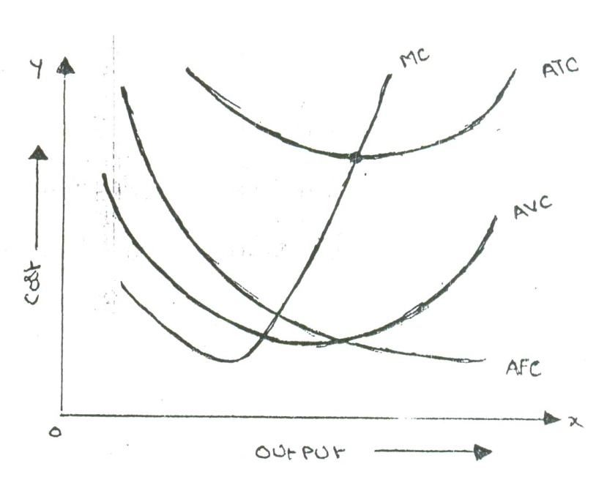

In the above graph the “AFC’ curve continues to fall as output rises an account of its spread over more and more units Output. But AVC curve (i.e. variable cost per unit) first falls and then rises due to the operation of the law of variable proportions. The behaviour of “ATC’ curve depends upon the behaviour of ‘AVC’ curve and ‘AFC’ curve. In the initial stage of production both ‘AVC’ and ‘AFC’ decline and hence ‘ATC’ also decline. But after a certain point ‘AVC’ starts rising. If the rise in variable cost is less than the decline in fixed cost, ATC will still continue to decline otherwise AC begins to rise. Thus the lower end of ‘ATC’ curve thus turns up and gives it a U-shape. That is why ‘ATC’ curve are U-shaped. The lowest point in ‘ATC’ curve indicates the least-cost combination of inputs. Where the total average cost is the minimum and where the “MC’ curve intersects ‘AC’ curve, It is not be the maximum output level rather it is the point where per unit cost of production will be at its lowest.

The relationship between ‘AVC’, ‘AFC’ and ‘ATC’ can be summarized up as follows:

1. If both AFC and ‘AVC’ fall, ‘ATC’ will also fall.
2. When ‘AFC’ falls and ‘AVC’ rises
3. ‘ATC’ will fall where the drop in ‘AFC’ is more than the raise in ‘AVC’.
4. ‘ATC’ remains constant is the drop in ‘AFC’ = rise in ‘AVC’
5. ‘ATC’ will rise where the drop in ‘AFC’ is less than the rise in ‘AVC’

**(b) Cost-output Relationship in the long-run:**

Long run is a period, during which all inputs are variable including the one, which are fixes in the short-run. In the long run a firm can change its output according to its demand. Over a long period, the size of the plant can be changed, unwanted buildings can be sold staff can be increased or reduced. The long run enables the firms to expand and scale of their operation by bringing or purchasing larger quantities of all the inputs. Thus in the long run all factors become variable. The long-run cost-output relations therefore imply the relationship between the total cost and the total output. In the long-run cost-output relationship is influenced by the law of returns to scale. In the long run a firm has a number of alternatives in regards to the scale of operations. For each scale of production or plant size, the firm has an appropriate short-run average cost curves. The short-run average cost (SAC) curve applies to only one plant whereas the long-run average cost (LAC) curve takes in to consideration many plants. The long-run cost-output relationship is shown graphically with the help of “LCA’ curve.

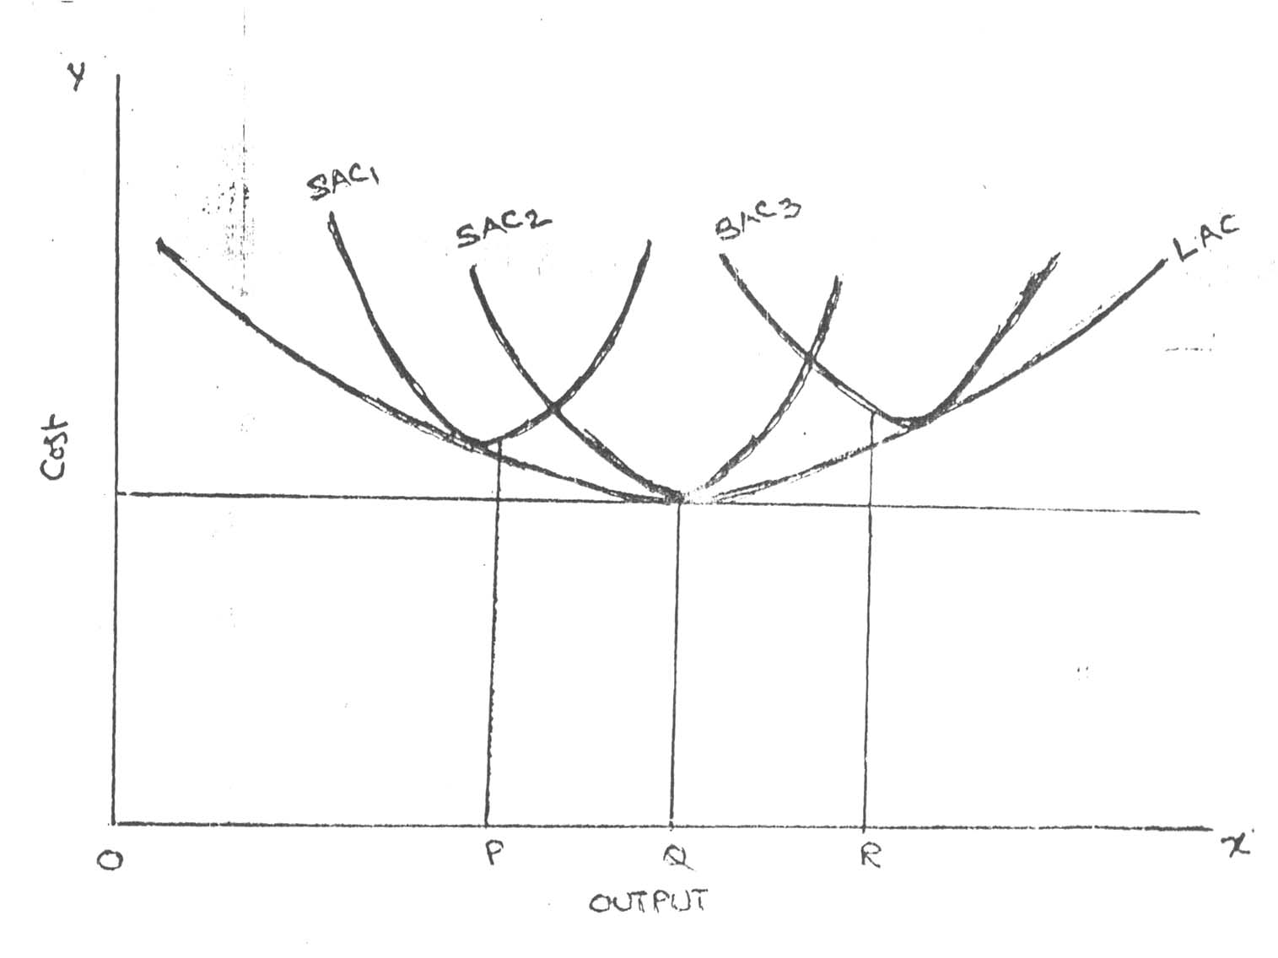

To draw on ‘LAC’ curve we have to start with a number of ‘SAC’ curves. In the above figure it is assumed that technologically there are only three sizes of plants – small, medium and large, ‘SAC’, for the small size, ‘SAC2’ for the medium size plant and ‘SAC3’ for the large size plant. If the firm wants to produce ‘OP’ units of output, it will choose the smallest plant. For an output beyond ‘OQ’ the firm wills optimum for medium size plant. It does not mean that the OQ production is not possible with small plant. Rather it implies that cost of production will be more with small plant compared to the medium plant.

For an output ‘OR’ the firm will choose the largest plant as the cost of production will be more with medium plant. Thus the firm has a series of ‘SAC’ curves. The ‘LCA’ curve drawn will be tangential to the entire family of ‘SAC’ curves i.e. the ‘LAC’ curve touches each ‘SAC’ curve at one point, and thus it is known as envelope curve. It is also known as planning curve as it serves as guide to the entrepreneur in his planning to expand the production in future. With the help of ‘LAC’ the firm determines the size of plant which yields the lowest average cost of producing a given volume of output it anticipates.

**BREAK-EVEN ANALYSIS**

The study of cost-volume-profit relationship is often referred as BEA. The term BEA is interpreted in two senses. In its narrow sense, it is concerned with finding out BEP; BEP is the point at which total revenue is equal to total cost. It is the point of no profit, no loss. In its broad determine the probable profit at any level of production.

**Assumptions:**

1. All costs are classified into two - fixed and variable.
2. Fixed costs remain constant at all levels of output.
3. Variable costs vary proportionally with the volume of output.
4. Selling price per unit remains constant in spite of competition or change in the volume of production.
5. There will be no change in operating efficiency.
6. There will be no change in the general price level.
7. Volume of production is the only factor affecting the cost.
8. Volume of sales and volume of production are equal. Hence there is no unsold stock.
9. There is only one product or in the case of multiple products. Sales mix remains constant.

**Merits:**

1. Information provided by the Break Even Chart can be understood more easily then those contained in the profit and Loss Account and the cost statement.
2. Break Even Chart discloses the relationship between cost, volume and profit. It reveals how changes in profit. So, it helps management in decision-making.
3. It is very useful for forecasting costs and profits long term planning and growth
4. The chart discloses profits at various levels of production.
5. It serves as a useful tool for cost control.
6. It can also be used to study the comparative plant efficiencies of the industry.
7. Analytical Break-even chart present the different elements, in the costs – direct material, direct labour, fixed and variable overheads.

**Demerits:**

1. Break-even chart presents only cost volume profits. It ignores other considerations such as capital amount, marketing aspects and effect of government policy etc., which are necessary in decision making.
2. It is assumed that sales, total cost and fixed cost can be represented as straight lines. In actual practice, this may not be so.
3. It assumes that profit is a function of output. This is not always true. The firm may increase the profit without increasing its output.
4. A major drawback of BEC is its inability to handle production and sale of multiple products.
5. It is difficult to handle selling costs such as advertisement and sale promotion in BEC.
6. It ignores economics of scale in production.
7. Fixed costs do not remain constant in the long run.
8. Semi-variable costs are completely ignored.
9. It assumes production is equal to sale. It is not always true because generally there may be opening stock.
10. When production increases variable cost per unit may not remain constant but may reduce on account of bulk buying etc.

The following are the important consideration terms used in analysing BEP:

* Fixed cost
* Variable cost
* Contribution
* Margin of safety
* Angle of incidence
* Profit volume ratio
* Break-Even-Point

**Fixed cost:**

Expenses that do not vary with the volume of production are known as fixed expenses. Eg. Manager’s salary, rent and taxes, insurance etc. It should be noted that fixed changes are fixed only within a certain range of plant capacity. The concept of fixed overhead is most useful in formulating a price fixing policy. Fixed cost per unit is not fixed.

**Variable Cost:**

Expenses that vary almost in direct proportion to the volume of production of sales are called variable expenses. Eg. Electric power and fuel, packing materials consumable stores. It should be noted that variable cost per unit is fixed.

**Contribution:**

Contribution is the difference between sales and variable costs and it contributed towards fixed costs and profit. It helps in sales and pricing policies and measuring the profitability of different proposals. Contribution is a sure test to decide whether a product is worthwhile to be continued among different products.

Contribution = Sales – Variable cost

Contribution = Fixed Cost + Profit.

**Margin of safety:**

Margin of safety is the excess of sales over the break even sales. It can be expressed in absolute sales amount or in percentage. It indicates the extent to which the sales can be reduced without resulting in loss. A large margin of safety indicates the soundness of the business. The formula for the margin of safety is:

Present sales – Break even sales **or** 

Margin of safety can be improved by taking the following steps.

* Increasing production
* Increasing selling price
* Reducing the fixed or the variable costs or both
* Substituting unprofitable product with profitable one.

**Angle of incidence:**

This is the angle between sales line and total cost line at the Break-even point. It indicates the profit earning capacity of the concern. Large angle of incidence indicates a high rate of profit; a small angle indicates a low rate of earnings. To improve this angle, contribution should be increased either by raising the selling price and/or by reducing variable cost. It also indicates as to what extent the output and sales price can be changed to attain a desired amount of profit.

**Profit Volume Ratio:**

Profit Volume Ratio is usually called P/V ratio. It is one of the most useful ratios for studying the profitability of business. The ratio of contribution to sales is the P/V ratio. It may be expressed in percentage. Therefore, every organization tries to improve the P/V ratio of each product by reducing the variable cost per unit or by increasing the selling price per unit. The concept of P/V ratio helps in determining break even-point, a desired amount of profit etc.

The formula is,  X 100

**Break – Even- Point:**

If we divide the term into three words, then it does not require further explanation.

Break-divide

Even-equal

Point-place or position

Break Even Point refers to the point where total cost is equal to total revenue. It is a point of no profit, no loss. This is also a minimum point of no profit, no loss. This is also a minimum point of production where total costs are recovered. If sales go up beyond the Break Even Point, organization makes a profit. If they come down, a loss is incurred.

Break Even point (Units) = 

Break Even point (In Rupees) = X sales